Project Identification

Project: | Customer Management System
Prepared By: | T16
Document Version: | 0.1
Published Date: | 12th October, 2021

Contributors
The following individuals contributed to this document.
Name | Title
Vishwa Mavani | Business Context Diagram, Requirements Scope Statements
Vatsal Bhimani | HLR Traceability, HLR Sign-Off

Distribution
This document is distributed to all the following people.
Name | Title
Anjana Shah | Course Professor

Referenced Documents
This document refers to the following materials
Version number | Title | Author | Date | Source / Location

Revision History

Version Number | Revision Date | Summary of Changes | Modified by
0.1 | 2021-10-12 | First draft for sprint 1 | Vishwa Mavani
[Note: It is recommended that drafts be numbered 0.1 to 0.9, and that the first approved version be numbered 1.0. Thereafter, new version numbers will depend upon changes: 1.01, 1.1, etc for minor updates, 2.0, 3.0 etc for major changes.]

TABLE OF CONTENTS
1. Business Context Diagram 2
2. REquirements Scope Statements 2
3. High Level Business Requirements (HLR) Traceability Error! Bookmark not defined.
4. High Level Business Requirements Sign-Off 2

- Business Context Diagram
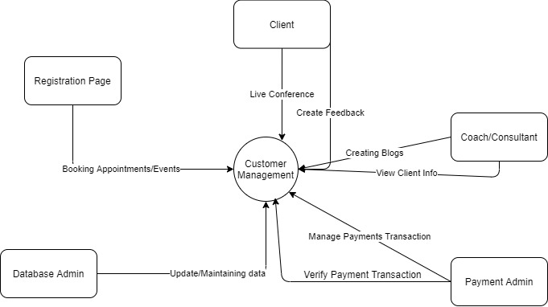

Requirement Scope Area | Description
Customer Management System | Area responsible for providing access to client for various purposes e.g. bookings, payment receipts, coach schedule availability, events etc.

External Entity | Description
Registration page | Area that generates documents such as payment confirmation receipts, booking confirmation, statements, and history.
Client | Clients can register and view the services they opt for, pay for the same, look at their past information, and book for events.
Coach/Consultant | Employee who can view client information and provide them according to their preferences.
Database Admin | Responsible for maintaining and updating database.
Payment Admin | All payments made on our platform are managed and verified

Information Flows | Description
System documents  (For management purposes) | The documents which hold information about clients and employees (personal information), received payments, bookings, workshops/webinars.
Client documents | The payment and booking slips that are generated and stored in the document services.
- Requirements Scope Statements
HLR# | Description | Priority  (H, M, L)
 | Registrants must be able to initiate registration. | H
 | Registrants must be able to review information online. | H
 | Registrants/Clients must receive notifications on their status. | H
HLR04 | Clients must receive their statements online. | H
HLR05 | Clients must be able to take survey/feedback at the end of their session. | H
HLR06 | Administrator must be able to add, delete and review past and upcoming events, workshops, and webinars. | H
HLR07 | Administrator/Employee must be able to create blogs. | H
HLR08 | Administrator must be able to retrieve the client information. | H
HLR09 | Administrator must be able to access the payments received, generate reports and attendance. | H
HLR10 | Administrator must be able to note down improvements and review financial statements. | H

- High Level Business Requirements (HLR) Traceability
Pages | Objectives | Description | Stakeholders | Need/Requirements | Implementation
Home page | Build a user-friendly environment | Have all the information regarding webinar, meeting, coach, blog. | Orbit5 | Must have details and links to other pages like, online registration. | Will start next term
Services Page | Build a user-friendly environment | It contains the services provided by organization to students | Orbit5 | Must have list of one-to-one and free weekly webinars | Will start next term
About Page | Build a user-friendly environment | Will depict the organization’s details like what are the goals of organization | Orbit5 | Should have contact details of organization or team members | Will start next term
Registration Page | Build a user-friendly environment | It’s a fill up form asks user to enter their details to stay up to date about meetings | Orbit5 | Must have form and stores information of clients to database | Will start next term
Blog Page | Build a user-friendly environment | It’s a feed which contains blogs of different coach, which can be seen by everybody. | Orbit5 | Should have blog posts of various instructor who gives guidance to students or clients | Will start next term
Payment Page | Build a user-friendly environment | Will contain methods of payment like PayPal, Debit card or Credit card, etc. | Orbit5 | Must have secured payment transaction configuration | Will start next term

- High Level Business Requirements Sign-Off
The undersigned acknowledge their agreement with the contents of Version 0.1 of the High-Level Requirements document for Customer Management System.

Following approval of this document, requirements changes will be governed by the project’s change management process, including impact analysis and appropriate reviews and approvals, under the general control of the Project Plan and according to company policy. Approved Change Request Documents, if present, will be attached to this Requirements Document as updates.

Name | Project Role and  Functional Area | Date Signed
Anjana Shah | Project Co-Ordinator
David Mendoza | Stakeholder

* Note: physical signatures are not required. Email approvals are acceptable and should be appended to project documents.

